**DAILY ONLINE ACTIVITIES SUMMARY**

|  |  |  |  |  |  |  |  |
| --- | --- | --- | --- | --- | --- | --- | --- |
| **Date:** | **16/06/2020** | | | | **Name:** | **Churashma** | |
| **Sem & Sec** | **4th SEM 'A' Section** | | | | **USN:** | **4AL18CS019** | |
| **Online Test Summary** | | | | | | | |
| **Subject** | | **Complex analysis, probability and statistical methods** | | | | | |
| **Max. Marks** | | **30** | | **Score** | | **24** | |
| **Certification Course Summary** | | | | | | | |
| **Course** | **Introduction to information security.** | | | | | | |
| **Certificate Provider** | | | **greatlearning academy** | **Duration** | | | **5.5 hours** |
| **Coding Challenges** | | | | | | | |
| **Problem statement 1: Write a c program to count the frequency of each element of an array.** | | | | | | | |
| **Status: completed** | | | | | | | |
| **Uploaded the report in Github** | | | | **yes** | | | |
| **If yes Repository name** | | | | **https://github.com/Churashma/Lockdown-coding** | | | |
| **Uploaded the report in slack** | | | | **yes** | | | |

ONLINE TEST DETAILS: Maths test was scheduled from 03:00pm to 03:40 pm .The portion for the IA was module 1 there were 15 questions and the time assigned was 40 minutes the questions were mcq type.

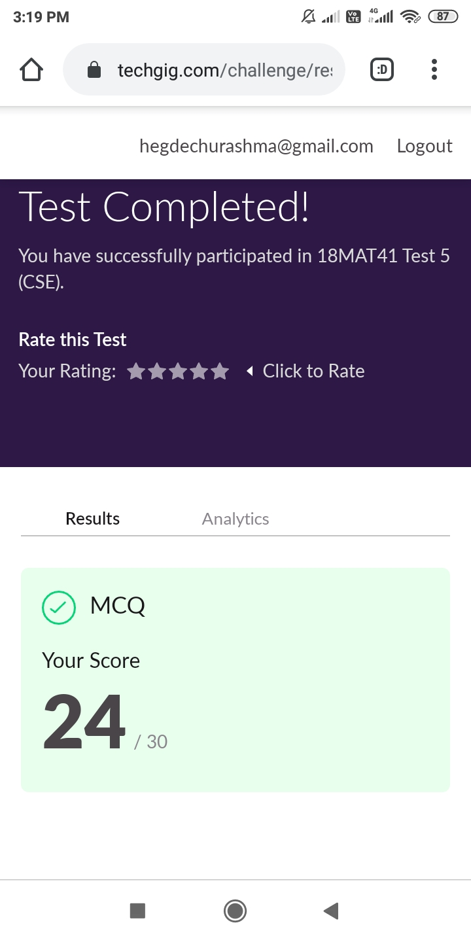

CERTIFICATION COURSE DETAILS: I started with the next certification course that is introduction to information security. In that I studied about what is the future of cryptographs and also I studied about Introduction to software security.Cryptographic systems are often built on the premise that certain math problems are, computationally, very hard to solve. Many of these problems, such as factoring certain types of large numbers, have been studied by mathematicians anywhere from decades to centuries. In fact, mathematicians often estimate the projected security of such systems by plotting the evolution in ‘running time’ of the best-known attacks.

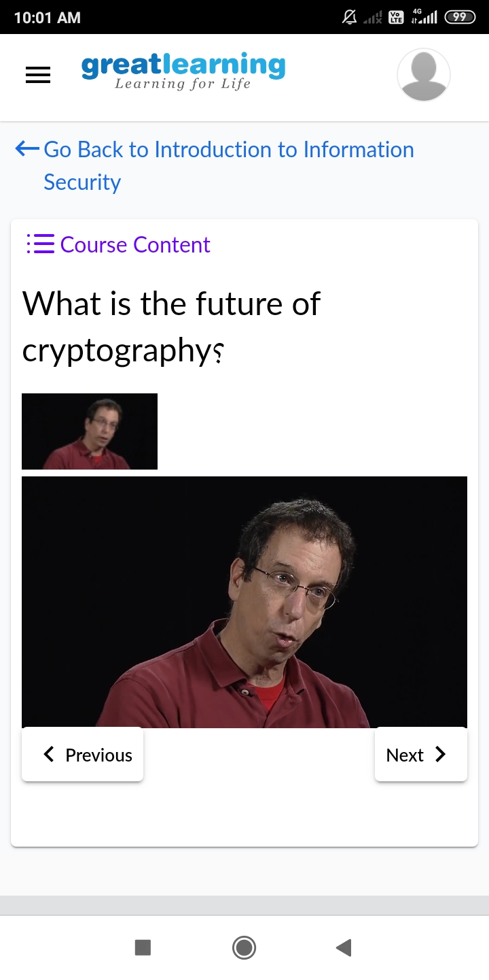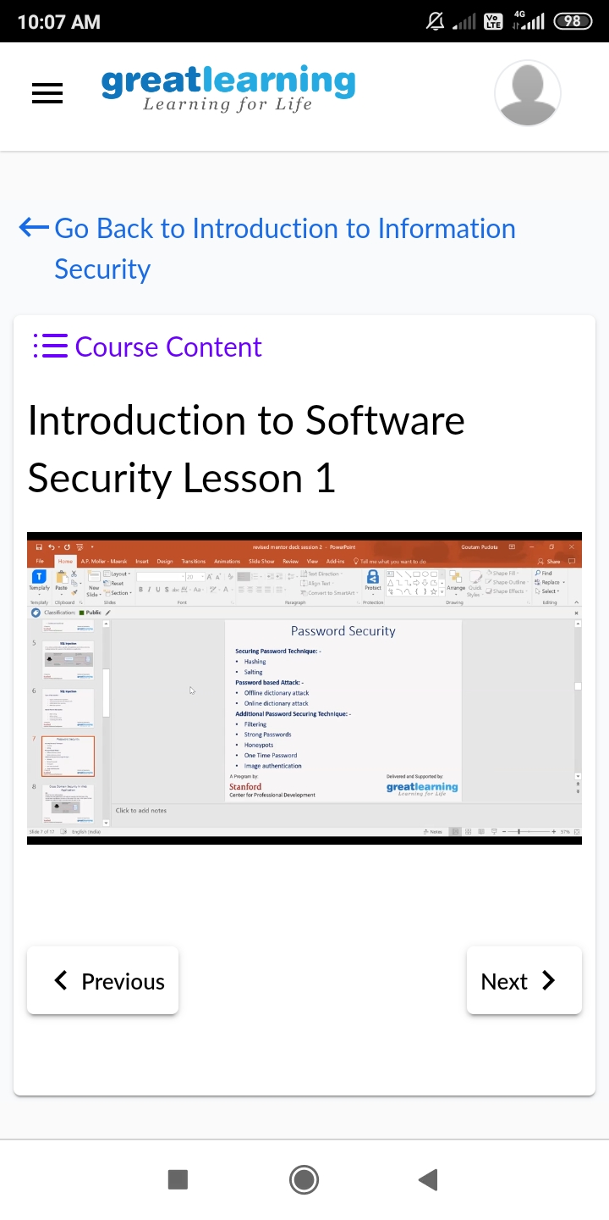

**CODING CHALLENGES DETAILS**:

**Problem statement 1:** Write a c program to count the frequency of each element of an array.

